​
​
UNITED STATES
SECURITIES AND EXCHANGE COMMISSION
Washington, D.C. 20549
Form 8-K
CURRENT REPORT
Pursuant to Section 13 or 15(d) of the Securities Exchange Act of 1934
Date of Report (Date of earliest event reported): August 6, 2026

HELIX ENERGY SOLUTIONS GROUP, INC.
(Exact name of registrant as specified in its charter)
​

​
​
​
Minnesota | 001-32936 | 95-3409686
(State or other jurisdiction  of incorporation) | (Commission  File Number) | (IRS Employer  Identification No.)
3505 West Sam Houston Parkway North | ​ | ​
Suite 400 | ​ | ​
Houston, Texas | ​ | 77043
(Address of principal executive offices) | ​ | (Zip Code)
​
Registrant’s telephone number, including area code: 281-618-0400
NOT APPLICABLE
(Former name or former address, if changed since last report)
Check the appropriate box below if the Form 8-K filing is intended to simultaneously satisfy the filing obligation of the registrant under any of the following provisions:
☐ Written communications pursuant to Rule 425 under the Securities Act (17 CFR 230.425)
☐ Soliciting material pursuant to Rule 14a-12 under the Exchange Act (17 CFR 240.14a-12)
☐ Pre-commencement communications pursuant to Rule 14d-2(b) under the Exchange Act (17 CFR 240.14d-2(b))
☐ Pre-commencement communications pursuant to Rule 13e-4(c) under the Exchange Act (17 CFR 240.13e-4(c))
Securities registered pursuant to Section 12(b) of the Act:
​

​ | ​ | ​ | ​ | ​
Title of each class | ​ | Trading Symbol(s) | ​ | Name of each exchange on which registered
Common Stock, no par value | ​ | HLX | ​ | New York Stock Exchange
​
Indicate by check mark whether the registrant is an emerging growth company as defined in Rule 405 of the Securities Act of 1933 (§230.405 of this chapter) or Rule 12b-2 of the Securities Exchange Act of 1934 (§240.12b-2 of this chapter).
Emerging growth company ☐
If an emerging growth company, indicate by check mark if the registrant has elected not to use the extended transition period for complying with any new or revised financial accounting standards provided pursuant to Section 13(a) of the Exchange Act. ☐
​
​
​
​
Item 2.02. Results of Operations and Financial Condition.
On August 6, 2026, Helix Energy Solutions Group, Inc. (“Helix”) issued a press release reporting its financial results for the second quarter 2026. The press release is furnished herewith as Exhibit 99.1 and incorporated herein by reference.
​
Item 7.01. Regulation FD Disclosure.
On August 6, 2026, Helix issued a press release reporting its financial results for the second quarter 2026. Due to the pending merger with Hornbeck Offshore Services, Inc., Helix will not host a conference call or webcast to discuss its second quarter 2026 results. Furnished herewith as Exhibits 99.1 and 99.2, respectively, and incorporated herein by reference, are the press release and the slides for the Second Quarter 2026 Earnings Presentation issued by Helix. The presentation materials are also available on the Investor Relations section of Helix’s website, www.helixesg.com.
The information furnished pursuant to Items 2.02 and 7.01, including Exhibits 99.1 and 99.2, shall not be deemed to be “filed” for the purposes of Section 18 of the Securities Exchange Act of 1934, as amended, and will not be incorporated by reference into any filing under the Securities Act of 1933, as amended, unless specifically identified therein as being incorporated therein by reference.
​
Item 9.01. Financial Statements and Exhibits.
(d) Exhibits.
​
​ | ​ | ​
Exhibit  Number | ​ ​ ​ | Description
99.1 | ​ | Press Release of Helix Energy Solutions Group, Inc. dated August 6, 2026 reporting financial results for the second quarter 2026.
99.2 | ​ | Second Quarter 2026 Earnings Presentation.
104 | ​ | Cover Page Interactive Data File (embedded within the Inline XBRL document).
​
​
​
SIGNATURES
Pursuant to the requirements of the Securities Exchange Act of 1934, the Registrant has duly caused this report to be signed on its behalf by the undersigned hereunto duly authorized.
​
Date: August 6, 2026 | ​ ​ ​ | ​
​ | ​ | HELIX ENERGY SOLUTIONS GROUP, INC.
​ | ​ | ​
 | ​ | By: | /s/ Erik Staffeldt
​ | ​ | ​ | Erik Staffeldt
​ | ​ | ​ | Executive Vice President and  Chief Financial Officer
​
​
​
EXHIBIT 99.1
​
​ | ​ | ​
 | ​ | PRESSRELEASE  www.helixesg.com
​
​ | ​ | ​ | ​ | ​ | ​ | ​ | ​ | ​
​ | ​ | ​ | ​ | ​ | ​ | ​ | ​ | ​
Helix Energy Solutions Group, Inc. | ● | 3505 W. Sam Houston Parkway N., Suite 400 | ● | Houston, TX 77043 | ● | 281-618-0400 | ● | fax: 281-618-0505
​ | ​ | ​ | ​ | ​ | ​ | ​ | ​ | ​
For Immediate Release |  | ​ | ​ | ​ | ​ | ​ | ​ | 26-009
​ | ​ | ​ | ​ | ​ | ​ | ​ | ​ | ​
Date: August 6, 2026 |  | Contact: | Erik Staffeldt |  | ​ | ​ | ​ | ​
​ | ​ | ​ | Executive Vice President & CFO |  |  |  | ​ | ​
​ | ​ | ​ | ​ |  | ​ | ​ | ​ | ​
​
Helix Reports Second Quarter 2026 Results
​
HOUSTON, TX – Helix Energy Solutions Group, Inc. (“Helix”) (NYSE: HLX) reported net income of $22.7 million, or $0.15 per diluted share, for the second quarter 2026 compared to a net loss of $13.4 million, or $(0.09) per diluted share, for the first quarter 2026 and a net loss of $2.6 million, or $(0.02) per diluted share, for the second quarter 2025. Helix reported Adjusted EBITDA1 of $69.9 million for the second quarter 2026 compared to $32.3 million for the first quarter 2026 and $42.4 million for the second quarter 2025.
​
For the six months ended June 30, 2026, Helix reported net income of $9.3 million, or $0.06 per diluted share, compared to net income of $0.5 million, or $0.00 per diluted share, for the six months ended June 30, 2025. Adjusted EBITDA for the six months ended June 30, 2026 was $102.1 million compared to $94.4 million for the six months ended June 30, 2025.
​
Included in our results are the operations and sale of Helix Alliance, which have been classified as discontinued operations in our financial statements. Net income (loss) of Helix Alliance reported in discontinued operations for the three and six-month periods ended June 30, 2026, was $7.5 million and $(0.7) million, respectively. Adjusted EBITDA from continuing operations for the three- and six-month periods ended June 30, 2026 was $74.7 million and $112.0 million, respectively.
​
The table below summarizes our results of operations:
​
Summary of Results
​
($ in thousands, except per share amounts, unaudited)
​
​ | ​ | ​ | ​ | ​ | ​ | ​ | ​ | ​ | ​ | ​ | ​ | ​ | ​ | ​ | ​ | ​
​ | ​ ​ ​ | Three Months Ended |  |  |  |  |  |  |  | ​ ​ ​ | Six Months Ended
​ | ​ | 6/30/2026 |  | ​ | 6/30/2025 |  | ​ | 3/31/2026 |  | ​ | 6/30/2026 |  | ​ | 6/30/2025
Revenues | ​ | $ | 304,016 | ​ | $ | 251,682 | ​ | $ | 266,710 | ​ | $ | 570,726 | ​ | $ | 512,980 | ​
Gross Profit | ​ | $ | 56,198 | ​ | $ | 13,454 | ​ | $ | 17,679 | ​ | $ | 73,877 | ​ | $ | 52,574 | ​
​ | ​ |  | 18 | % |  | 5 | % |  | 7 | % |  | 13 | % |  | 10 | %
Income (Loss) from Continuing Operations | ​ | $ | 15,265 | ​ | $ | (5,062) | ​ | $ | (5,242) | ​ | $ | 10,023 | ​ | $ | 6,322 | ​
Income (Loss) from Discontinued Operations | ​ | ​ | 7,455 | ​ | ​ | 2,464 | ​ | ​ | (8,164) | ​ | ​ | (709) | ​ | ​ | (5,848) | ​
Net Income (Loss) | ​ | $ | 22,720 | ​ | $ | (2,598) | ​ | $ | (13,406) | ​ | $ | 9,314 | ​ | $ | 474 | ​
Diluted Earnings (Loss) Per Share from Continuing Operations | ​ | $ | 0.10 | ​ | $ | (0.04) | ​ | $ | (0.04) | ​ | $ | 0.07 | ​ | $ | 0.04 | ​
Diluted Earnings (Loss) Per Share from Discontinued Operations | ​ | ​ | 0.05 | ​ | ​ | 0.02 | ​ | ​ | (0.05) | ​ | ​ | (0.01) | ​ | ​ | (0.04) | ​
Diluted Earnings (Loss) Per Share | ​ | $ | 0.15 | ​ | $ | (0.02) | ​ | $ | (0.09) | ​ | $ | 0.06 | ​ | $ | 0.00 | ​
Adjusted EBITDA from Continuing Operations | ​ | $ | 74,673 | ​ | $ | 36,639 | ​ | $ | 37,370 | ​ | $ | 112,043 | ​ | $ | 96,195 | ​
Adjusted EBITDA from Discontinued Operations | ​ | ​ | (4,823) | ​ | ​ | 5,791 | ​ | ​ | (5,108) | ​ | ​ | (9,931) | ​ | ​ | (1,780) | ​
Adjusted EBITDA1 | ​ | $ | 69,850 | ​ | $ | 42,430 | ​ | $ | 32,262 | ​ | $ | 102,112 | ​ | $ | 94,415 | ​
Cash and Cash Equivalents2 | ​ | $ | 652,234 | ​ | $ | 319,743 | ​ | $ | 501,272 | ​ | $ | 652,234 | ​ | $ | 319,743 | ​
Net Debt1,2 | ​ | $ | (347,929) | ​ | $ | (8,131) | ​ | $ | (197,511) | ​ | $ | (347,929) | ​ | $ | (8,131) | ​
Operating Cash Flows | ​ | $ | 53,897 | ​ | $ | (17,133) | ​ | $ | 61,786 | ​ | $ | 115,683 | ​ | $ | (691) | ​
Free Cash Flow1 | ​ | $ | 46,720 | ​ | $ | (21,603) | ​ | $ | 58,975 | ​ | $ | 105,695 | ​ | $ | (9,649) | ​
​
​
​
1 Adjusted EBITDA, Net Debt and Free Cash Flow are non-GAAP measures; see reconciliations below
2 Cash and Cash Equivalents and Net Debt include cash and cash equivalents from both continuing and discontinued operations

Owen Kratz, President and Chief Executive Officer of Helix, stated, “Helix generated significant cash flows from operations in the second quarter and year to date. Combined with the cash from the disposition of Helix Alliance in May, we are positioned with $652 million of cash and $717 million of liquidity. Our business performance for the year is progressing as previously outlined, with positive international activity offsetting weaker domestic output. We continue to work towards consummating our merger with Hornbeck and currently expect the merger to be completed promptly following our shareholder meeting scheduled for August 31, 2026 subject to customary closing conditions. In light of the pending merger, we are withdrawing our previously issued annual guidance.”
​
Segment Information, Operational and Financial Highlights
​
($ in thousands, unaudited)
​
​ | ​ | ​ | ​ | ​ | ​ | ​ | ​ | ​ | ​ | ​ | ​ | ​ | ​ | ​ | ​
​ | ​ ​ ​ | Three Months Ended |  |  |  |  |  |  |  | ​ ​ ​ | Six Months Ended
​ | ​ | 6/30/2026 |  | ​ | 6/30/2025 |  | ​ | 3/31/2026 |  | ​ | 6/30/2026 |  | ​ | 6/30/2025
Revenues: |  | ​ | ​ |  | ​ | ​ |  | ​ | ​ |  | ​ | ​ |  | ​ | ​
Well Intervention | ​ | $ | 208,092 | ​ | $ | 156,786 | ​ | $ | 209,443 | ​ | $ | 417,535 | ​ | $ | 355,160
Robotics | ​ |  | 76,436 | ​ |  | 85,572 | ​ |  | 62,373 | ​ |  | 138,809 | ​ |  | 136,614
Production Facilities | ​ |  | 29,723 | ​ |  | 17,081 | ​ |  | 18,736 | ​ |  | 48,459 | ​ |  | 36,918
Intercompany Eliminations | ​ |  | (10,235) | ​ |  | (7,757) | ​ |  | (23,842) | ​ |  | (34,077) | ​ |  | (15,712)
Total | ​ | $ | 304,016 | ​ | $ | 251,682 | ​ | $ | 266,710 | ​ | $ | 570,726 | ​ | $ | 512,980
​ | ​ | ​ | ​ | ​ | ​ | ​ | ​ | ​ | ​ | ​ | ​ | ​ | ​ | ​ | ​
Income (Loss) from Operations: | ​ | ​ | ​ | ​ | ​ | ​ | ​ | ​ | ​ | ​ | ​ | ​ | ​ | ​ | ​
Well Intervention | ​ | $ | 19,349 | ​ | $ | (16,430) | ​ | $ | 10,857 | ​ | $ | 30,206 | ​ | $ | 3,540
Robotics | ​ |  | 14,187 | ​ |  | 19,044 | ​ |  | 7,773 | ​ |  | 21,960 | ​ |  | 24,391
Production Facilities | ​ |  | 15,805 | ​ |  | 4,425 | ​ |  | (7,909) | ​ |  | 7,896 | ​ |  | 11,369
Corporate / Other / Eliminations | ​ |  | (22,626) | ​ |  | (10,081) | ​ |  | (13,473) | ​ |  | (36,099) | ​ |  | (20,921)
Total | ​ | $ | 26,715 | ​ | $ | (3,042) | ​ | $ | (2,752) | ​ | $ | 23,963 | ​ | $ | 18,379
​
Segment Results
​
Well Intervention
​
Well Intervention revenues decreased $1.4 million, or 1%, during the second quarter 2026 compared to the prior quarter with reduced revenues on the Q7000, Q4000 and Sea Helix 1, nearly entirely offset by higher seasonal revenues in the North Sea. The Q7000 completed its project for Shell in Brazil in April and spent the remainder of the quarter transiting and mobilizing to West Africa, during which time all revenues and mobilization costs were deferred. During the second quarter, the Q4000 incurred an annual out-of-service period and gaps in its schedule, and the Sea Helix 1 commenced its five-year docking mid-June. In addition to revenues from higher seasonal utilization in the North Sea, the Q5000 also had improved utilization during the second quarter following its planned approximate two-week maintenance period during the prior quarter. Overall Well Intervention vessel utilization increased to 91% during the second quarter 2026 compared to 82% during the prior quarter, although the second quarter included transit and mobilization during which revenues were deferred which accounted for approximately 9% of utilization. Well Intervention operating income increased $8.5 million during the second quarter 2026 compared to the prior quarter primarily due to cost deferrals on the Q7000, lower repairs and maintenance on the Q5000 and operating leverage resulting in higher incremental margins in the North Sea.
​
Well Intervention revenues increased $51.3 million, or 33%, during the second quarter 2026 compared to the second quarter 2025. The increase was primarily due to higher utilization on the Q5000, which underwent a 57-day planned regulatory docking during the second quarter 2025, and on the Seawell, which was idle throughout 2025. Revenues also increased on the Q4000, which spent 45 days demobilizing during the second quarter 2025 during which period no revenues were recognized. Revenue increases in 2026 were partially offset by lower revenues on the Q7000, which spent May through June transiting and mobilizing to West Africa, during which time all revenues and mobilization costs were deferred, and on the Sea Helix 1, which commenced its five-year regulatory docking mid-June. Overall Well Intervention vessel utilization increased to 91% during the second quarter 2026 compared to 72% during the second quarter 2025. Well Intervention operating income increased $35.8 million during the second quarter 2026 compared to the second quarter 2025 primarily due to higher revenues and higher incremental margins during the second quarter 2026.
​

Robotics
​
Robotics revenues increased $14.1 million, or 23%, during the second quarter 2026 compared to the prior quarter due to the expected seasonally higher activity levels with increased trenching and ROV activities. During the second quarter our overall ROV and trencher utilization increased to 67% compared to 56% during the prior quarter. Overall vessel activity decreased slightly to 374 days during the second quarter compared to 381 days during the prior quarter with a reduction in utilization on the Grand Canyon II, which transitioned to the North Sea during the quarter, offset partially by a full quarter of utilization on the MV Patriot following its commencement of operations during the prior quarter. Although overall vessel activity decreased, integrated vessel trenching increased from 122 days during the prior quarter to 171 days during the second quarter, and site clearance operations increased from 110 days during the prior quarter to 137 days during the second quarter. Third-party trenching remained flat quarter over quarter. Robotics operating income increased $6.4 million compared to the prior quarter primarily due to higher revenues.
​
Robotics revenues decreased $9.1 million, or 11%, during the second quarter 2026 compared to the second quarter 2025. Revenue decreases were primarily due to lower vessel activities, which were impacted by the Grand Canyon II transition to the North Sea during the quarter, offset partially by increased ROV and trenching activities during the second quarter 2026. The second quarter 2026 included 374 total vessel days, or 69% utilization, compared to 537 vessel days, or 95% utilization, during the second quarter 2025. Site clearance operations decreased from 190 days during the second quarter 2025 to 137 days during the second quarter 2026, and integrated vessel trenching increased from 157 days during the second quarter 2025 to 171 days during the second quarter 2026. Overall ROV and trencher utilization increased to 67% compared to 62% during the second quarter 2025. Robotics operating income decreased $4.9 million during the second quarter 2026 primarily due lower revenues.
​
Production Facilities
​
Production Facilities revenues increased $11.0 million, or 59%, during the second quarter 2026 compared to the prior quarter primarily due to higher oil and gas production and prices from the Thunder Hawk field, which recommenced production early April 2026 following a successful workover after having been shut in since 2024. Production Facilities generated operating income of $15.8 million during the second quarter 2026 compared to an operating loss of $7.9 million during the prior quarter, primarily due to higher revenues during the second quarter 2026 and workover costs on the Thunder Hawk field during the prior quarter.
​
Production Facilities revenues increased $12.6 million, or 74%, during the second quarter 2026 compared to the second quarter 2025 primarily due to higher oil and gas production and prices following the recommencement of operations on the Thunder Hawk field early April 2026. Production Facilities operating income increased $11.4 million during the second quarter 2026 compared to the second quarter 2025 primarily due to higher revenues during the second quarter 2026.
​
Selling, General and Administrative and Other
​
Transaction-Related Costs
​
Acquisition and integration costs during the second quarter totaled $8.3 million and are related to our merger with Hornbeck and primarily include legal and professional fees.
​
Selling, General and Administrative
​
Selling, general and administrative expenses were $21.1 million, or 7.0% of revenue, during the second quarter 2026 compared to $20.4 million, or 7.7% of revenue, during the prior quarter and $16.5 million, or 6.6% of revenue, during the second quarter 2025. The increase in expenses quarter over quarter was primarily due to higher employee compensation during the second quarter 2026.
​
Other Income and Expense
​
Other expense, net was $0.2 million during the second quarter 2026 compared to other income, net of $0.3 million and $0.4 million during the prior quarter and the second quarter 2025, respectively. Other income and expense, net primarily includes net foreign currency gains and losses related to our international subsidiaries’ foreign currency positions.
​
Income from Discontinued Operations
​
Income (loss) from discontinued operations relates to Helix Alliance, which was sold on May 1, 2026 and constituted our entire Shallow Water Abandonment segment. Income from discontinued operations during the three months ended June 30, 2026, includes one month of net income for Helix Alliance as well as a gain on sale of Helix Alliance of $12.7 million, net of tax expense of $3.4 million on the gain.
​

Cash Flows
​
Operating cash flows were $53.9 million during the second quarter 2026 compared to $61.8 million during the prior quarter and $(17.1) million during the second quarter 2025. Operating cash flows decreased compared to the prior quarter primarily due lower working capital inflows offset partially by higher earnings during the second quarter 2026. Operating cash flows increased compared to the second quarter 2025 primarily due to higher earnings and working capital inflows and lower regulatory certification costs for our vessels and systems during the second quarter 2026. Regulatory certifications costs for our vessels and systems in our continuing operations, which are included in operating cash flows, were $4.6 million during the second quarter 2026 compared to $3.8 million during the prior quarter and $14.1 million during the second quarter 2025.
​
Capital expenditures for our continuing operations, which are included in investing cash flows, totaled $7.2 million during the second quarter 2026 compared to $2.8 million during the prior quarter and $4.3 million during the second quarter 2025. During the second quarter 2026, investing cash flows provided by discontinued operations included the proceeds from the sale of Helix Alliance of approximately $104.2 million, net of $3.3 million cash sold.
​
Free Cash Flow was $46.7 million during the second quarter 2026 compared to $59.0 million during the prior quarter and $(21.6) million during the second quarter 2025. (Free Cash Flow is a non-GAAP measure. See reconciliation below.)
​
Financial Condition and Liquidity
​
Cash and cash equivalents were $652.2 million at June 30, 2026. Available capacity under our ABL facility at June 30, 2026 was $66.9 million, and total liquidity was $716.5 million, excluding $2.6 million cash pledged toward our ABL facility. Consolidated long-term debt was $304.3 million at June 30, 2026, resulting in negative Net Debt of $347.9 million. (Net Debt is a non-GAAP measure. See reconciliation below.)
​
Transaction Update
​
Helix is making progress towards the consummation of its previously announced merger with Hornbeck. On June 4, 2026, Helix filed a Registration Statement on Form S-4 (the “Form S-4”) with the Securities and Exchange Commission (the “SEC”), which was declared effective July 31, 2026. The transaction has been approved by the Boards of Directors of both companies. Helix expects that the merger will be completed September 1, 2026, subject to the approval of our shareholders at the Special Meeting scheduled for August 31, 2026 and other customary closing conditions.
​
* * * * *
​
Conference Call Information
​
Due to the pending merger with Hornbeck, we will not host a conference call or webcast to discuss our second quarter 2026 results. We have provided further details of our second quarter 2026 results in a presentation provided on our Investor Relations page of Helix’s website, www.helixesg.com.
​
About Helix
​
Helix Energy Solutions Group, Inc., headquartered in Houston, Texas, is an international offshore energy services company that provides specialty services to the offshore energy industry, with a focus on well intervention, robotics and decommissioning operations. Our services are key in supporting a global energy transition by maximizing production of existing oil and gas reserves, decommissioning end-of-life oil and gas fields and supporting renewable energy developments. For more information about Helix, please visit our website at www.helixesg.com.
​
Non-GAAP Financial Measures
​
Management evaluates operating performance and financial condition using certain non-GAAP measures, primarily Adjusted EBITDA, Free Cash Flow and Net Debt. We define Adjusted EBITDA as earnings before income taxes, net interest expense, depreciation and amortization expense, net other income or expense, gains or losses on disposition of assets, long-lived asset impairment losses, transaction-related costs, gains or losses related to convertible senior notes, the change in fair value of contingent consideration, and the general provision for (release of) current expected credit losses, if any. We define Free Cash Flow as cash flows from operating activities less capital expenditures, net of proceeds from asset sales and insurance recoveries (related to property and equipment), if any. Net Debt is calculated as long-term debt including current maturities of long-term debt less cash and cash equivalents and restricted cash.
​

We use Adjusted EBITDA, Free Cash Flow and Net Debt to monitor and facilitate internal evaluation of the performance of our business operations, to facilitate external comparison of our business results to those of others in our industry, to analyze and evaluate financial and strategic planning decisions regarding future investments and acquisitions, to plan and evaluate operating budgets, and in certain cases, to report our results to the holders of our debt as required by our debt covenants. We believe that our measures of Adjusted EBITDA, Free Cash Flow and Net Debt provide useful information to the public regarding our operating performance and ability to service debt and fund capital expenditures and may help our investors understand and compare our results to other companies that have different financing, capital and tax structures. Other companies may calculate their measures of Adjusted EBITDA, Free Cash Flow and Net Debt differently from the way we do, which may limit their usefulness as comparative measures. Adjusted EBITDA, Free Cash Flow and Net Debt should not be considered in isolation or as a substitute for, but instead are supplemental to, income from operations, net income, cash flows from operating activities, or other income or cash flow data prepared in accordance with GAAP. Users of this financial information should consider the types of events and transactions that are excluded from these measures. See reconciliation of the non-GAAP financial information presented in this press release to the most directly comparable financial information presented in accordance with GAAP. We have not provided reconciliations of forward-looking non-GAAP financial measures to comparable GAAP measures due to the challenges and impracticability with estimating some of the items without unreasonable effort, which amounts could be significant.
​
Forward-Looking Statements
​
This press release contains forward-looking statements that involve risks, uncertainties and assumptions that could cause our results to differ materially from those expressed or implied by such forward-looking statements. All statements, other than statements of historical fact, are “forward-looking statements” within the meaning of the Private Securities Litigation Reform Act of 1995, including, without limitation, any statements regarding: our plans, strategies and objectives for future operations; our proposed merger with Hornbeck; any projections of financial items including projections as to guidance and other outlook information; future operations expenditures; our ability to enter into, renew and/or perform commercial contracts; the spot market; our current work continuing; visibility and future utilization; our protocols and plans; future economic or political conditions; energy transition or energy security; our spending and cost management efforts and our ability to manage changes; oil price volatility and its effects and results; our ability to identify, effect and integrate mergers, acquisitions, joint ventures, divestitures or other transactions; developments; any financing transactions or arrangements or our ability to enter into such transactions or arrangements; our sustainability initiatives; our share repurchase program or execution; any statements of expectation or belief; and any statements of assumptions underlying any of the foregoing. Forward-looking statements are subject to a number of known and unknown risks, uncertainties and other factors that could cause results to differ materially from those in the forward-looking statements, including but not limited to market conditions and the demand for our services; volatility of oil and natural gas prices; complexities of global political and economic developments, including tariffs; results from mergers, acquisitions, joint ventures, divestitures or similar transactions; the ultimate timing, outcome and results of integrating our and Hornbeck’s operations, including difficulties and delays relating to such integration and/or delays in realizing anticipated synergies, cost savings and other expected benefits of the transactions, if at all; results from acquired properties; our ability to secure and realize backlog; the performance of contracts by customers, suppliers and other counterparties; actions by governmental and regulatory authorities; operating hazards and delays, which include delays in delivery, chartering or customer acceptance of assets or terms of their acceptance; the effectiveness of our sustainability initiatives and disclosures; human capital management issues; geologic risks; and other risks described from time to time in our filings with the SEC, including our most recently filed Annual Report on Form 10-K, our subsequent reports on Form 10-Q and our registration statement on Form S-4 filed in connection with the proposed Hornbeck merger, which are available free of charge on the SEC’s website at www.sec.gov. We assume no obligation and do not intend to update these forward-looking statements, which speak only as of their respective dates, except as required by law.

HELIX ENERGY SOLUTIONS GROUP, INC.
​
Comparative Condensed Consolidated Statements of Operations
​
​ | ​ | ​ | ​ | ​ | ​ | ​ | ​ | ​ | ​ | ​ | ​ | ​ | ​
​ | ​ | ​ ​ ​ | Three Months Ended Jun. 30, |  |  |  |  | ​ ​ ​ | Six Months Ended Jun. 30,
(in thousands, except per share data) | ​ | ​ | 2026 |  | ​ | 2025 |  | ​ | 2026 |  | ​ | 2025
​ | ​ | ​ | (unaudited) |  |  |  |  | ​ | (unaudited)
​ | ​ | ​ | ​ | ​ | ​ | ​ | ​ | ​ | ​ | ​ | ​ | ​ | ​
Net revenues | ​ | ​ | $ | 304,016 | ​ | $ | 251,682 | ​ | $ | 570,726 | ​ | $ | 512,980
Cost of sales | ​ | ​ |  | 247,818 | ​ |  | 238,228 | ​ |  | 496,849 | ​ |  | 460,406
Gross profit | ​ | ​ |  | 56,198 | ​ |  | 13,454 | ​ |  | 73,877 | ​ |  | 52,574
Transaction-related costs |  | ​ | ​ | (8,340) | ​ | ​ | — | ​ | ​ | (8,340) | ​ | ​ | —
Selling, general and administrative expenses |  | ​ |  | (21,143) | ​ |  | (16,496) | ​ |  | (41,574) | ​ |  | (34,195)
Income (loss) from operations |  | ​ |  | 26,715 | ​ |  | (3,042) | ​ |  | 23,963 | ​ |  | 18,379
Net interest expense | ​ | ​ |  | (4,372) | ​ |  | (6,176) | ​ |  | (9,781) | ​ |  | (12,213)
Other income (expense), net |  | ​ |  | (154) | ​ |  | 437 | ​ |  | 144 | ​ |  | 80
Royalty income and other |  | ​ |  | 218 | ​ |  | (5) | ​ |  | 1,906 | ​ |  | 1,411
Income (loss) from continuing operations before income taxes |  | ​ |  | 22,407 | ​ |  | (8,786) | ​ |  | 16,232 | ​ |  | 7,657
Income tax provision (benefit) |  | ​ |  | 7,142 | ​ |  | (3,724) | ​ |  | 6,209 | ​ |  | 1,335
Income (loss) from continuing operations |  | ​ | ​ | 15,265 | ​ | ​ | (5,062) | ​ | ​ | 10,023 | ​ | ​ | 6,322
Income (loss) from discontinued operations, net of tax |  | ​ | ​ | 7,455 | ​ | ​ | 2,464 | ​ | ​ | (709) | ​ | ​ | (5,848)
Net income (loss) | ​ | ​ | $ | 22,720 | ​ | $ | (2,598) | ​ | $ | 9,314 | ​ | $ | 474
​ | ​ | ​ | ​ | ​ | ​ | ​ | ​ | ​ | ​ | ​ | ​ | ​ | ​
Basic and diluted earnings (loss) per share of common stock: |  | ​ | ​ | ​ | ​ | ​ | ​ | ​ | ​ | ​ | ​ | ​ | ​
Continuing operations | ​ | ​ | $ | 0.10 | ​ | $ | (0.04) | ​ | $ | 0.07 | ​ | $ | 0.04
Discontinued operations | ​ | ​ | ​ | 0.05 | ​ | ​ | 0.02 | ​ | ​ | (0.01) | ​ | ​ | (0.04)
Net income (loss) per common share |  | ​ | $ | 0.15 | ​ | $ | (0.02) | ​ | $ | 0.06 | ​ | $ | 0.00
​ | ​ | ​ | ​ | ​ | ​ | ​ | ​ | ​ | ​ | ​ | ​ | ​ | ​
Weighted average common shares outstanding: |  | ​ | ​ | ​ | ​ | ​ | ​ | ​ | ​ | ​ | ​ | ​ | ​
Basic | ​ | ​ |  | 147,220 | ​ |  | 148,515 | ​ |  | 147,192 | ​ |  | 149,770
Diluted | ​ | ​ |  | 148,107 | ​ |  | 148,515 | ​ |  | 148,002 | ​ |  | 150,539
​
​

​
Comparative Condensed Consolidated Balance Sheets
​
​ | ​ | ​ | ​ | ​ | ​ | ​ | ​
​ | ​ | ​ ​ ​ | Jun. 30, 2026 |  | ​ ​ ​ | Dec. 31, 2025
(in thousands) | ​ | ​ | (unaudited)
​ | ​ | ​ | ​ | ​ | ​ | ​ | ​
ASSETS | ​ |  | ​ | ​ |  | ​ | ​
​ | ​ | ​ | ​ | ​ | ​ | ​ | ​
Current Assets: | ​ |  | ​ | ​ |  | ​ | ​
Cash and cash equivalents | ​ | ​ | $ | 652,234 | ​ | $ | 418,289
Accounts receivable, net | ​ | ​ |  | 204,864 | ​ |  | 240,604
Other current assets | ​ | ​ |  | 82,368 | ​ |  | 65,321
Current assets of discontinued operations |  | ​ | ​ | — | ​ | ​ | 100,778
Total Current Assets | ​ | ​ |  | 939,466 | ​ |  | 824,992
​ | ​ | ​ | ​ | ​ | ​ | ​ | ​
Property and equipment, net | ​ | ​ |  | 1,232,621 | ​ |  | 1,289,481
Operating lease right-of-use assets | ​ | ​ |  | 287,061 | ​ |  | 301,711
Deferred recertification and dry dock costs, net |  | ​ | ​ | 56,059 | ​ | ​ | 69,959
Other assets, net | ​ | ​ | ​ | 54,811 | ​ | ​ | 50,442
Non-current assets of discontinued operations |  | ​ |  | — | ​ |  | 79,319
Total Assets | ​ | ​ | $ | 2,570,018 | ​ | $ | 2,615,904
​ | ​ | ​ | ​ | ​ | ​ | ​ | ​
LIABILITIES AND SHAREHOLDERS' EQUITY |  | ​ | ​ | ​ | ​ | ​ | ​
​ | ​ | ​ | ​ | ​ | ​ | ​ | ​
Current Liabilities: | ​ | ​ | ​ | ​ | ​ | ​ | ​
Accounts payable | ​ | ​ | $ | 124,049 | ​ | $ | 111,587
Accrued liabilities | ​ | ​ |  | 72,758 | ​ |  | 90,965
Current maturities of long-term debt | ​ | ​ |  | 9,516 | ​ |  | 9,644
Current operating lease liabilities | ​ | ​ |  | 64,794 | ​ |  | 60,208
Current liabilities of discontinued operations |  | ​ |  | — | ​ |  | 27,274
Total Current Liabilities | ​ | ​ |  | 271,117 | ​ |  | 299,678
​ | ​ | ​ | ​ | ​ | ​ | ​ | ​
Long-term debt | ​ | ​ |  | 294,789 | ​ |  | 298,351
Operating lease liabilities | ​ | ​ |  | 241,299 | ​ |  | 260,608
Deferred tax liabilities | ​ | ​ |  | 104,765 | ​ |  | 105,571
Other non-current liabilities | ​ | ​ |  | 74,392 | ​ |  | 71,433
Non-current liabilities of discontinued operations |  | ​ |  | — | ​ |  | 351
Shareholders' equity | ​ | ​ |  | 1,583,656 | ​ |  | 1,579,912
Total Liabilities and Equity | ​ | ​ | $ | 2,570,018 | ​ | $ | 2,615,904
​
​

HELIX ENERGY SOLUTIONS GROUP, INC.
​
​
Comparative Condensed Consolidated Statements of Cash Flows
​
​ | ​ | ​ | ​ | ​ | ​ | ​ | ​
​ | ​ | ​ | Six Months Ended
(in thousands) | ​ | ​ ​ ​ | 6/30/2026 |  | ​ ​ ​ | 6/30/2025
​ | ​ | ​ | (unaudited)
Cash flows from operating activities: | ​ |  | ​ | ​ | ​ | ​ | ​
Net income | ​ | ​ | $ | 9,314 | ​ | $ | 474
Less: Loss from discontinued operations, net of tax |  | ​ | ​ | 709 | ​ | ​ | 5,848
Income from continuing operations |  | ​ | ​ | 10,023 | ​ | ​ | 6,322
Adjustments to reconcile income from continuing operations to net cash provided by (used in) continuing operating activities: |  | ​ |  | ​ | ​ |  | ​
Depreciation and amortization | ​ | ​ |  | 77,875 | ​ |  | 76,292
Deferred certification and dry dock costs |  | ​ | ​ | (8,412) | ​ | ​ | (30,571)
Other non-cash charges |  | ​ | ​ | 4,283 | ​ | ​ | 2,386
Changes in operating assets and liabilities |  | ​ |  | 17,733 | ​ |  | (55,502)
Net cash provided by (used in) continuing operating activities |  | ​ |  | 101,502 | ​ |  | (1,073)
Net cash provided by discontinued operating activities |  | ​ | ​ | 14,181 | ​ | ​ | 382
Net cash provided by (used in) operating activities |  | ​ | ​ | 115,683 | ​ | ​ | (691)
​ | ​ | ​ | ​ | ​ | ​ | ​ | ​
Cash flows from investing activities: | ​ | ​ |  | ​ | ​ |  | ​
Capital expenditures | ​ | ​ |  | (9,988) | ​ |  | (8,580)
Net cash used in continuing investing activities |  | ​ |  | (9,988) | ​ |  | (8,580)
Net cash provided by (used in) discontinued investing activities |  | ​ | ​ | 104,208 | ​ | ​ | (378)
Net cash provided by (used in) investing activities |  | ​ | ​ | 94,220 | ​ | ​ | (8,958)
​ | ​ | ​ | ​ | ​ | ​ | ​ | ​
Cash flows from financing activities: | ​ | ​ |  | ​ | ​ |  | ​
Repayments of long-term debt | ​ | ​ |  | (4,763) | ​ |  | (4,537)
Repurchases of common stock and payments of related excise tax |  | ​ | ​ | (151) | ​ | ​ | (30,214)
Other financing activities | ​ | ​ |  | 890 | ​ |  | (6,029)
Net cash used in continuing financing activities |  | ​ | ​ | (4,024) | ​ | ​ | (40,780)
Net cash used in financing activities |  | ​ |  | (4,024) | ​ |  | (40,780)
​ | ​ | ​ | ​ | ​ | ​ | ​ | ​
Effect of exchange rate changes on cash and cash equivalents |  | ​ |  | 1,159 | ​ |  | 2,142
Net increase (decrease) in cash and cash equivalents |  | ​ |  | 207,038 | ​ |  | (48,287)
Cash and cash equivalents (1): | ​ | ​ |  | ​ | ​ |  | ​
Balance, beginning of year | ​ | ​ |  | 445,196 | ​ |  | 368,030
Balance, end of period | ​ | ​ | $ | 652,234 | ​ | $ | 319,743
​
(1) Includes cash and cash equivalents of continuing and discontinued operations
​
​

​
Reconciliation of Non-GAAP Measures
​
​ | ​ | ​ | ​ | ​ | ​ | ​ | ​ | ​ | ​ | ​ | ​ | ​ | ​ | ​ | ​ | ​ | ​
​ | ​ | ​ | ​ ​ ​ | Three Months Ended |  |  |  |  |  |  |  | ​ ​ ​ | Six Months Ended
(in thousands, unaudited) | ​ | ​ | ​ | 6/30/2026 |  | ​ | 6/30/2025 |  | ​ | 3/31/2026 |  | ​ | 6/30/2026 |  | ​ | 6/30/2025
​ | ​ | ​ | ​ | ​ | ​ | ​ | ​ | ​ | ​ | ​ | ​ | ​ | ​ | ​ | ​ | ​ | ​
Reconciliation from Net Income (Loss) to Adjusted EBITDA: |  |  |  | ​ | ​ |  | ​ | ​ |  | ​ | ​ |  | ​ | ​ |  | ​ | ​
Net income (loss) | ​ | ​ | ​ | $ | 22,720 | ​ | $ | (2,598) | ​ | $ | (13,406) | ​ | $ | 9,314 | ​ | $ | 474
Less: Income (loss) from discontinued operations |  |  | ​ | ​ | (7,455) | ​ | ​ | (2,464) | ​ | ​ | 8,164 | ​ | ​ | 709 | ​ | ​ | 5,848
Income (loss) from continuing operations |  |  | ​ | ​ | 15,265 | ​ | ​ | (5,062) | ​ | ​ | (5,242) | ​ | ​ | 10,023 | ​ | ​ | 6,322
Adjustments: | ​ | ​ | ​ | ​ | ​ | ​ | ​ | ​ | ​ | ​ | ​ | ​ | ​ | ​ | ​ | ​ | ​
Income tax provision (benefit) | ​ | ​ | ​ |  | 7,142 | ​ |  | (3,724) | ​ |  | (933) | ​ |  | 6,209 | ​ |  | 1,335
Net interest expense | ​ | ​ | ​ |  | 4,372 | ​ |  | 6,176 | ​ |  | 5,409 | ​ |  | 9,781 | ​ |  | 12,213
Depreciation and amortization | ​ | ​ | ​ |  | 39,466 | ​ |  | 39,488 | ​ |  | 38,409 | ​ |  | 77,875 | ​ |  | 76,292
Other (income) expense, net | ​ | ​ | ​ |  | 154 | ​ |  | (437) | ​ |  | (298) | ​ |  | (144) | ​ |  | (80)
Transaction-related costs | ​ | ​ | ​ | ​ | 8,340 | ​ | ​ | — | ​ | ​ | — | ​ | ​ | 8,340 | ​ | ​ | —
General provision for (release of) current expected credit losses |  |  | ​ |  | (66) | ​ |  | 198 | ​ |  | 25 | ​ |  | (41) | ​ |  | 113
Adjusted EBITDA from continuing operations |  |  | ​ | ​ | 74,673 | ​ | ​ | 36,639 | ​ | ​ | 37,370 | ​ | ​ | 112,043 | ​ | ​ | 96,195
Adjusted EBITDA from discontinued operations |  |  | ​ | ​ | (4,823) | ​ | ​ | 5,791 | ​ | ​ | (5,108) | ​ | ​ | (9,931) | ​ | ​ | (1,780)
Adjusted EBITDA | ​ | ​ | ​ | $ | 69,850 | ​ | $ | 42,430 | ​ | $ | 32,262 | ​ | $ | 102,112 | ​ | $ | 94,415
​ | ​ | ​ | ​ | ​ | ​ | ​ | ​ | ​ | ​ | ​ | ​ | ​ | ​ | ​ | ​ | ​ | ​
Free Cash Flow: | ​ | ​ | ​ | ​ | ​ | ​ | ​ | ​ | ​ | ​ | ​ | ​ | ​ | ​ | ​ | ​ | ​
Cash flows from continuing operating activities |  |  | ​ | $ | 53,707 | ​ | $ | (4,629) | ​ | $ | 47,795 | ​ | $ | 101,502 | ​ | $ | (1,073)
Less: Net capital expenditures from continuing operations |  |  | ​ |  | (7,177) | ​ |  | (4,306) | ​ |  | (2,811) | ​ |  | (9,988) | ​ |  | (8,580)
Free Cash Flow from continuing operations |  | ​ | ​ | ​ | 46,530 | ​ | ​ | (8,935) | ​ | ​ | 44,984 | ​ | ​ | 91,514 | ​ | ​ | (9,653)
Free Cash Flow from discontinued operations |  |  | ​ | ​ | 190 | ​ | ​ | (12,668) | ​ | ​ | 13,991 | ​ | ​ | 14,181 | ​ | ​ | 4
Free Cash Flow | ​ | ​ | ​ | $ | 46,720 | ​ | $ | (21,603) | ​ | $ | 58,975 | ​ | $ | 105,695 | ​ | $ | (9,649)
​ | ​ | ​ | ​ | ​ | ​ | ​ | ​ | ​ | ​ | ​ | ​ | ​ | ​ | ​ | ​ | ​ | ​
Net Debt: | ​ | ​ | ​ | ​ | ​ | ​ | ​ | ​ | ​ | ​ | ​ | ​ | ​ | ​ | ​ | ​ | ​
Long-term debt including current maturities |  | ​ | ​ | $ | 304,305 | ​ | $ | 311,612 | ​ | $ | 303,761 | ​ | $ | 304,305 | ​ | $ | 311,612
Less: Cash and cash equivalents (1) |  |  | ​ |  | (652,234) | ​ |  | (319,743) | ​ |  | (501,272) | ​ |  | (652,234) | ​ |  | (319,743)
Net Debt | ​ | ​ | ​ | $ | (347,929) | ​ | $ | (8,131) | ​ | $ | (197,511) | ​ | $ | (347,929) | ​ | $ | (8,131)
​
(1) Includes cash and cash equivalents of continuing and discontinued operations

 | 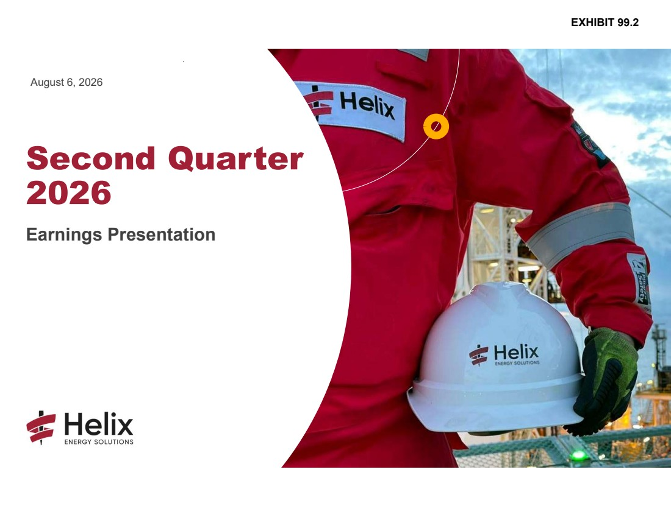 | August 6, 2026 Second Quarter 2026 Earnings Presentation EXHIBIT 99.2
 | 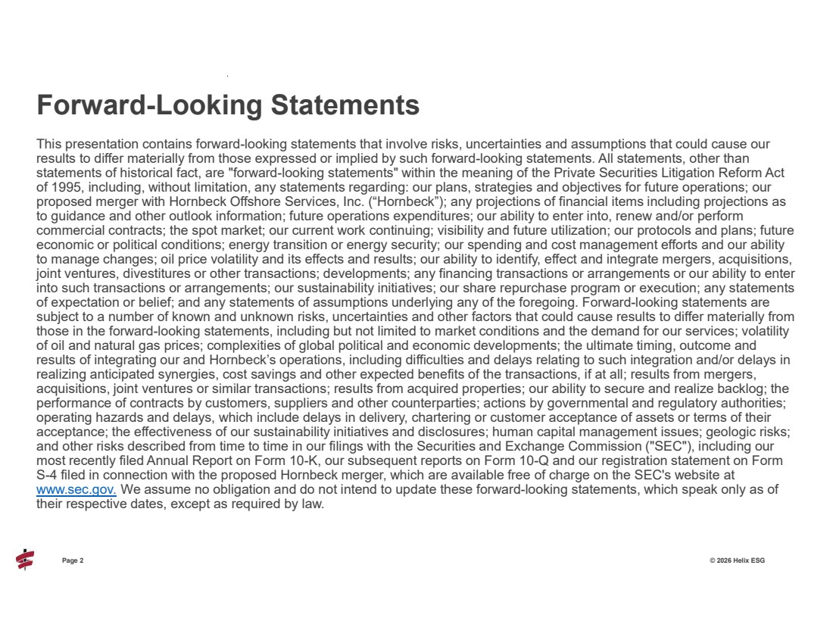 | Page 2 © 2026 Helix ESG This presentation contains forward-looking statements that involve risks, uncertainties and assumptions that could cause our results to differ materially from those expressed or implied by such forward-looking statements. All statements, other than statements of historical fact, are "forward-looking statements" within the meaning of the Private Securities Litigation Reform Act of 1995, including, without limitation, any statements regarding: our plans, strategies and objectives for future operations; our proposed merger with Hornbeck Offshore Services, Inc. (“Hornbeck”); any projections of financial items including projections as to guidance and other outlook information; future operations expenditures; our ability to enter into, renew and/or perform commercial contracts; the spot market; our current work continuing; visibility and future utilization; our protocols and plans; future economic or political conditions; energy transition or energy security; our spending and cost management efforts and our ability to manage changes; oil price volatility and its effects and results; our ability to identify, effect and integrate mergers, acquisitions, joint ventures, divestitures or other transactions; developments; any financing transactions or arrangements or our ability to enter into such transactions or arrangements; our sustainability initiatives; our share repurchase program or execution; any statements of expectation or belief; and any statements of assumptions underlying any of the foregoing. Forward-looking statements are subject to a number of known and unknown risks, uncertainties and other factors that could cause results to differ materially from those in the forward-looking statements, including but not limited to market conditions and the demand for our services; volatility of oil and natural gas prices; complexities of global political and economic developments; the ultimate timing, outcome and results of integrating our and Hornbeck’s operations, including difficulties and delays relating to such integration and/or delays in realizing anticipated synergies, cost savings and other expected benefits of the transactions, if at all; results from mergers, acquisitions, joint ventures or similar transactions; results from acquired properties; our ability to secure and realize backlog; the performance of contracts by customers, suppliers and other counterparties; actions by governmental and regulatory authorities; operating hazards and delays, which include delays in delivery, chartering or customer acceptance of assets or terms of their acceptance; the effectiveness of our sustainability initiatives and disclosures; human capital management issues; geologic risks; and other risks described from time to time in our filings with the Securities and Exchange Commission ("SEC"), including our most recently filed Annual Report on Form 10-K, our subsequent reports on Form 10-Q and our registration statement on Form S-4 filed in connection with the proposed Hornbeck merger, which are available free of charge on the SEC's website at www.sec.gov. We assume no obligation and do not intend to update these forward-looking statements, which speak only as of their respective dates, except as required by law. Forward-Looking Statements
 | 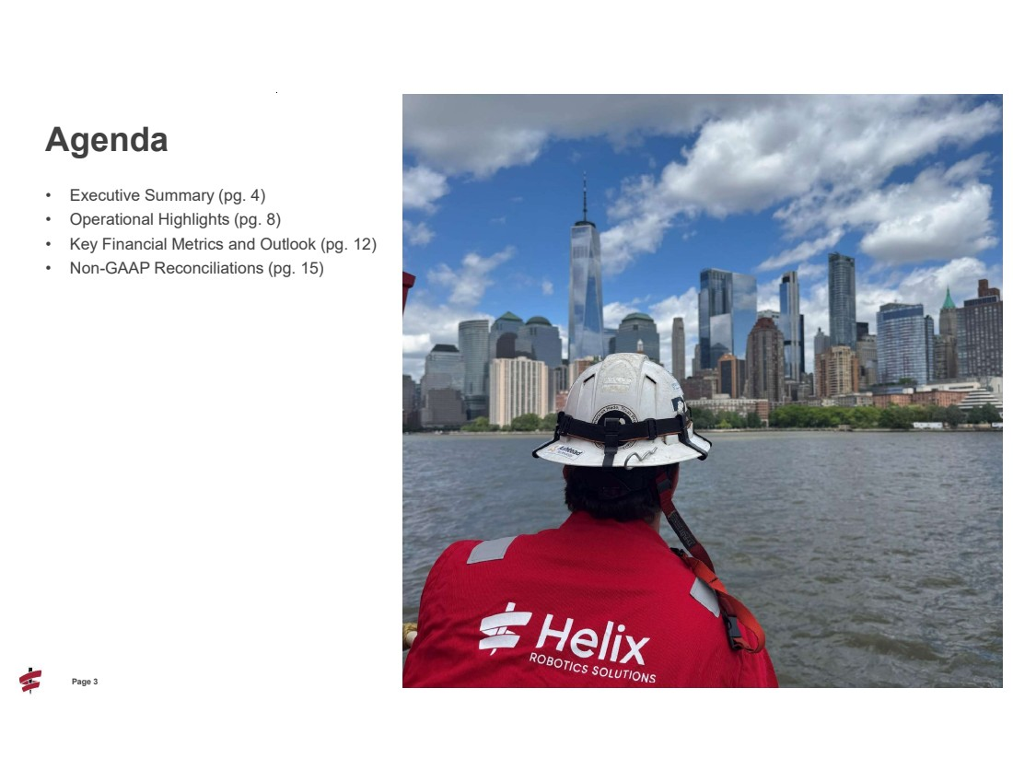 | 3 Page 3 © 2026 Helix ESG • Executive Summary (pg. 4) • Operational Highlights (pg. 8) • Key Financial Metrics and Outlook (pg. 12) • Non-GAAP Reconciliations (pg. 15) Agenda
 | 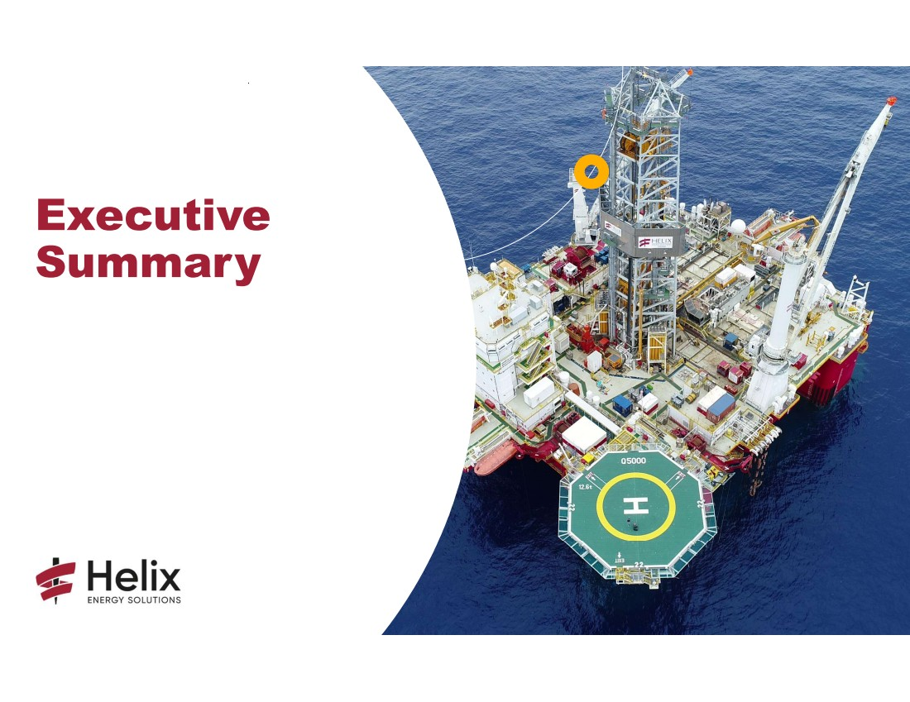 | Executive Summary
 | 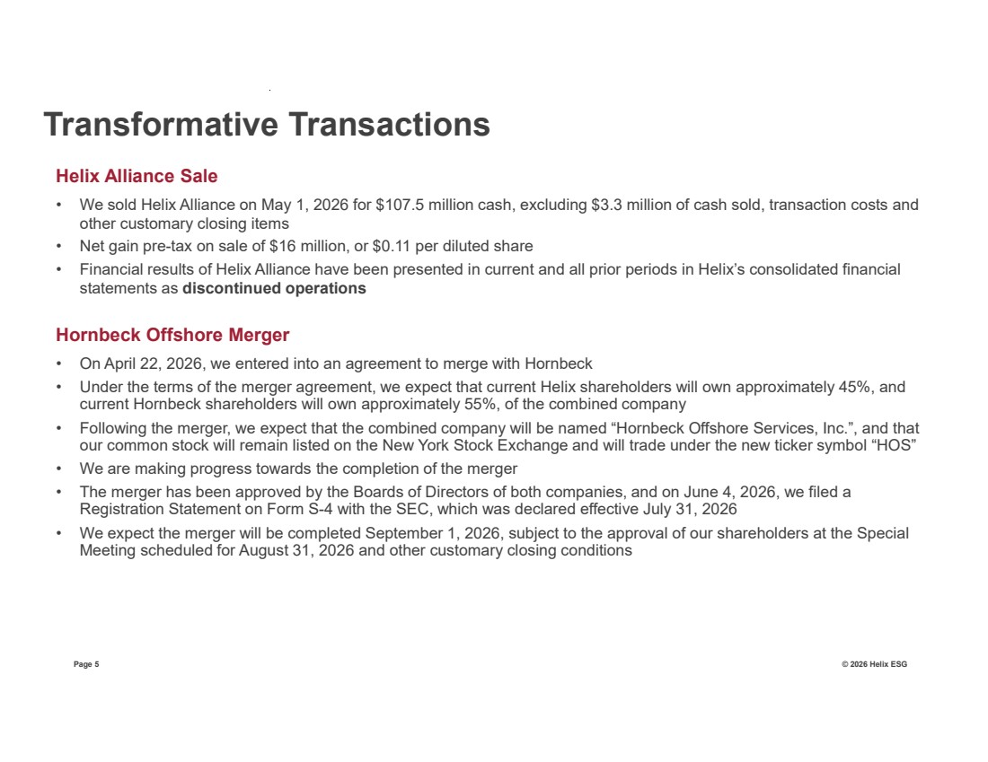 | Page 5 © 2026 Helix ESG Helix Alliance Sale • We sold Helix Alliance on May 1, 2026 for $107.5 million cash, excluding $3.3 million of cash sold, transaction costs and other customary closing items • Net gain pre-tax on sale of $16 million, or $0.11 per diluted share • Financial results of Helix Alliance have been presented in current and all prior periods in Helix’s consolidated financial statements as discontinued operations Hornbeck Offshore Merger • On April 22, 2026, we entered into an agreement to merge with Hornbeck • Under the terms of the merger agreement, we expect that current Helix shareholders will own approximately 45%, and current Hornbeck shareholders will own approximately 55%, of the combined company • Following the merger, we expect that the combined company will be named “Hornbeck Offshore Services, Inc.”, and that our common stock will remain listed on the New York Stock Exchange and will trade under the new ticker symbol “HOS” • We are making progress towards the completion of the merger • The merger has been approved by the Boards of Directors of both companies, and on June 4, 2026, we filed a Registration Statement on Form S-4 with the SEC, which was declared effective July 31, 2026 • We expect the merger will be completed September 1, 2026, subject to the approval of our shareholders at the Special Meeting scheduled for August 31, 2026 and other customary closing conditions Transformative Transactions
 | 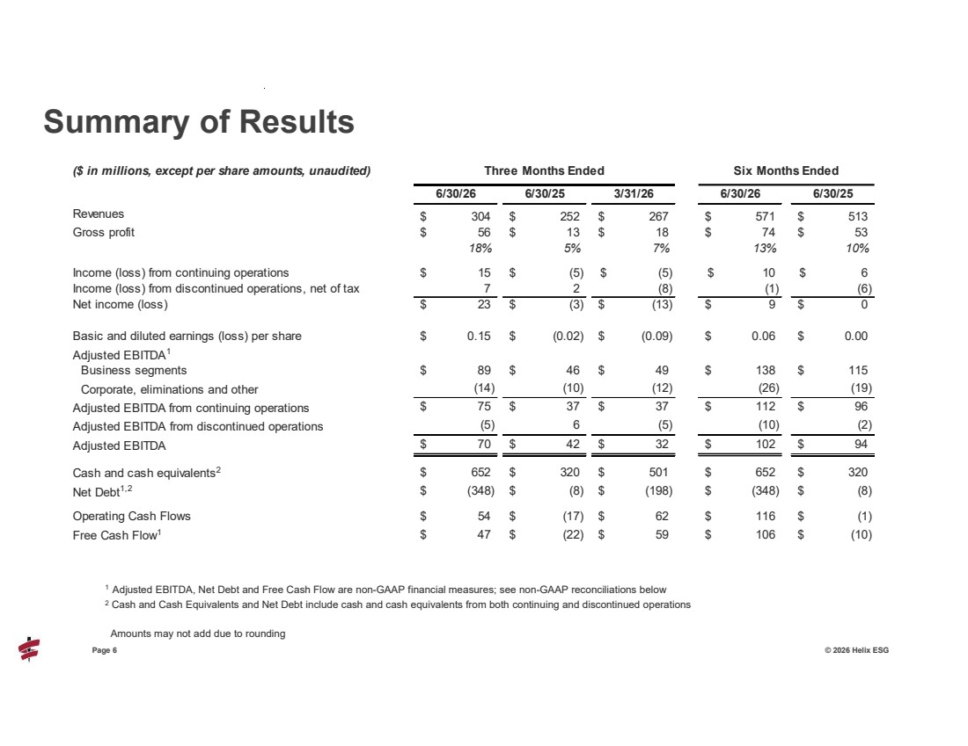 | 6 Page 6 © 2026 Helix ESG Summary of Results ($ in millions, except per share amounts, unaudited) Three Months Ended 6/30/26 6/30/25 3/31/26 6/30/26 6/30/25 Revenues $ 252 304 $ 267 $ 571 $ 513 $ Gross profit 56 $ 13 $ 18 $ 74 $ 53 $ 18% 5% 7% 13% 10% Income (loss) from continuing operations 15 $ (5) $ (5) $ 10 $ 6 $ Income (loss) from discontinued operations, net of tax 7 2 (8) (1) (6) Net income (loss) 23 $ (3) $ (13) $ 9 $ 0 $ Basic and diluted earnings (loss) per share 0.15 $ (0.02) $ (0.09) $ 0.06 $ 0.00 $ Adjusted EBITDA1 Business segments 89 $ 46 $ 49 $ 138 $ 115 $ Corporate, eliminations and other (10) (14) (12) (26) (19) Adjusted EBITDA from continuing operations $ 37 75 $ 37 $ 112 $ 96 $ Adjusted EBITDA from discontinued operations 6 (5) (5) (10) (2) Adjusted EBITDA $ 42 70 $ 32 $ 102 $ 94 $ Cash and cash equivalents2 $ 320 652 $ 501 $ 652 $ 320 $ Net Debt1,2 $ (8) (348) $ (198) $ (348) $ (8) $ Operating Cash Flows 54 $ (17) $ 62 $ 116 $ (1) $ Free Cash Flow1 $ (22) 47 $ 59 $ 106 $ (10) $ Six Months Ended 1 Adjusted EBITDA, Net Debt and Free Cash Flow are non-GAAP financial measures; see non-GAAP reconciliations below 2 Cash and Cash Equivalents and Net Debt include cash and cash equivalents from both continuing and discontinued operations Amounts may not add due to rounding
 | 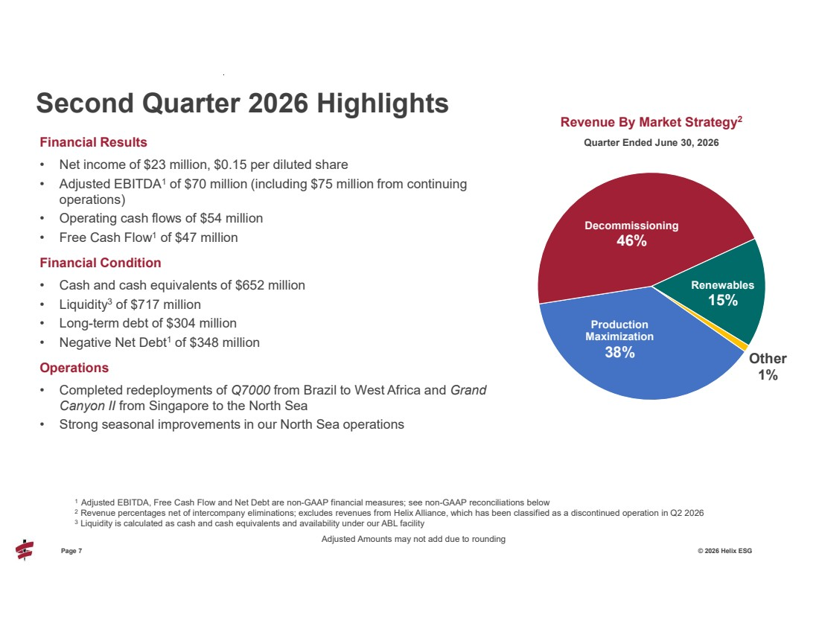 | Page 7 © 2026 Helix ESG Financial Results • Net income of $23 million, $0.15 per diluted share • Adjusted EBITDA1 of $70 million (including $75 million from continuing operations) • Operating cash flows of $54 million • Free Cash Flow1 of $47 million Financial Condition • Cash and cash equivalents of $652 million • Liquidity3 of $717 million • Long-term debt of $304 million • Negative Net Debt1 of $348 million Operations • Completed redeployments of Q7000 from Brazil to West Africa and Grand Canyon II from Singapore to the North Sea • Strong seasonal improvements in our North Sea operations Second Quarter 2026 Highlights 1 Adjusted EBITDA, Free Cash Flow and Net Debt are non-GAAP financial measures; see non-GAAP reconciliations below 2 Revenue percentages net of intercompany eliminations; excludes revenues from Helix Alliance, which has been classified as a discontinued operation in Q2 2026 3 Liquidity is calculated as cash and cash equivalents and availability under our ABL facility Production Maximization 38% Decommissioning 46% Renewables 15% Other 1% Revenue By Market Strategy2 Quarter Ended June 30, 2026 Adjusted Amounts may not add due to rounding
 | 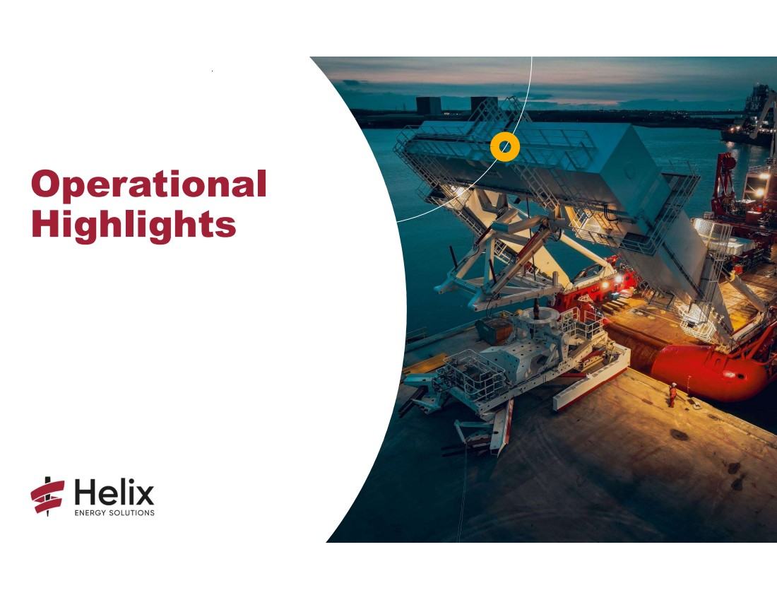 | Operational Highlights
 | 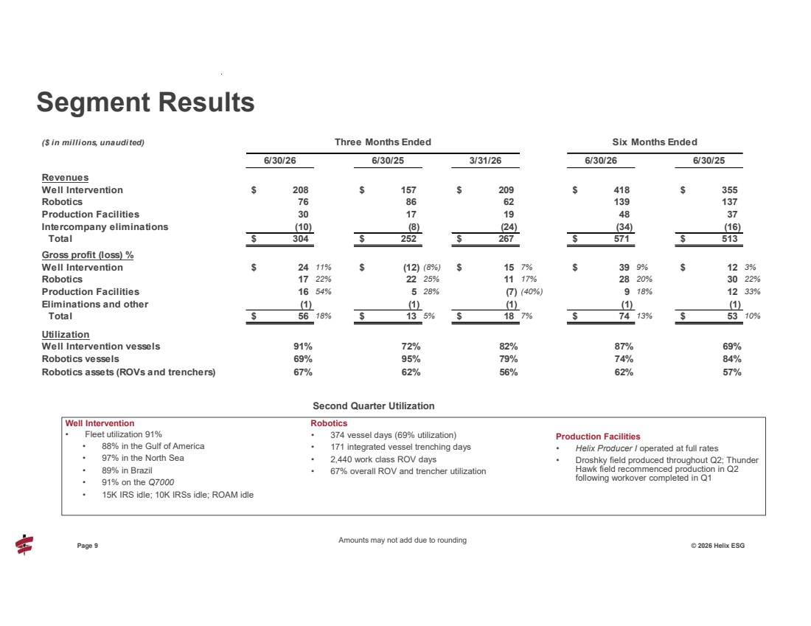 | 9 Page 9 © 2026 Helix ESG Well Intervention • Fleet utilization 91% • 88% in the Gulf of America • 97% in the North Sea • 89% in Brazil • 91% on the Q7000 • 15K IRS idle; 10K IRSs idle; ROAM idle Robotics • 374 vessel days (69% utilization) • 171 integrated vessel trenching days • 2,440 work class ROV days • 67% overall ROV and trencher utilization Production Facilities • Helix Producer I operated at full rates • Droshky field produced throughout Q2; Thunder Hawk field recommenced production in Q2 following workover completed in Q1 Segment Results ($ in millions, unaudited) Three Months Ended Six Months Ended 6/30/26 6/30/25 3/31/26 6/30/26 6/30/25 Revenues Well Intervention 208 $ 157 $ 209 $ 418 $ 355 $ Robotics 76 86 62 139 137 Production Facilities 30 17 19 48 37 Intercompany eliminations (10) (8) (24) (34) (16) Total 304 $ 252 $ 267 $ 571 $ 513 $ Gross profit (loss) % Well Intervention 24 $ 11% $ (12) (8%) $ 15 7% $ 39 9% $ 12 3% Robotics 17 22% 22 25% 11 17% 28 20% 30 22% Production Facilities 16 54% 5 28% (7) (40%) 9 18% 12 33% Eliminations and other (1) (1) (1) (1) (1) Total 56 $ 18% $ 13 5% $ 18 7% $ 74 13% $ 53 10% Utilization Well Intervention vessels 91% 72% 82% 87% 69% Robotics vessels 69% 95% 79% 74% 84% Robotics assets (ROVs and trenchers) 67% 62% 56% 62% 57% Amounts may not add due to rounding Second Quarter Utilization
 | 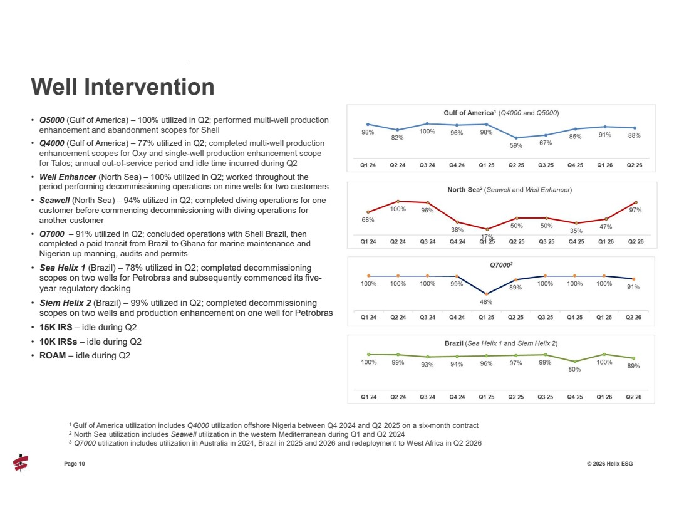 | 10 Page 10 © 2026 Helix ESG • Q5000 (Gulf of America) – 100% utilized in Q2; performed multi-well production enhancement and abandonment scopes for Shell • Q4000 (Gulf of America) – 77% utilized in Q2; completed multi-well production enhancement scopes for Oxy and single-well production enhancement scope for Talos; annual out-of-service period and idle time incurred during Q2 • Well Enhancer (North Sea) – 100% utilized in Q2; worked throughout the period performing decommissioning operations on nine wells for two customers • Seawell (North Sea) – 94% utilized in Q2; completed diving operations for one customer before commencing decommissioning with diving operations for another customer • Q7000 – 91% utilized in Q2; concluded operations with Shell Brazil, then completed a paid transit from Brazil to Ghana for marine maintenance and Nigerian up manning, audits and permits • Sea Helix 1 (Brazil) – 78% utilized in Q2; completed decommissioning scopes on two wells for Petrobras and subsequently commenced its five-year regulatory docking • Siem Helix 2 (Brazil) – 99% utilized in Q2; completed decommissioning scopes on two wells and production enhancement on one well for Petrobras • 15K IRS – idle during Q2 • 10K IRSs – idle during Q2 • ROAM – idle during Q2 Well Intervention 1 Gulf of America utilization includes Q4000 utilization offshore Nigeria between Q4 2024 and Q2 2025 on a six-month contract 2 North Sea utilization includes Seawell utilization in the western Mediterranean during Q1 and Q2 2024 3 Q7000 utilization includes utilization in Australia in 2024, Brazil in 2025 and 2026 and redeployment to West Africa in Q2 2026
 | 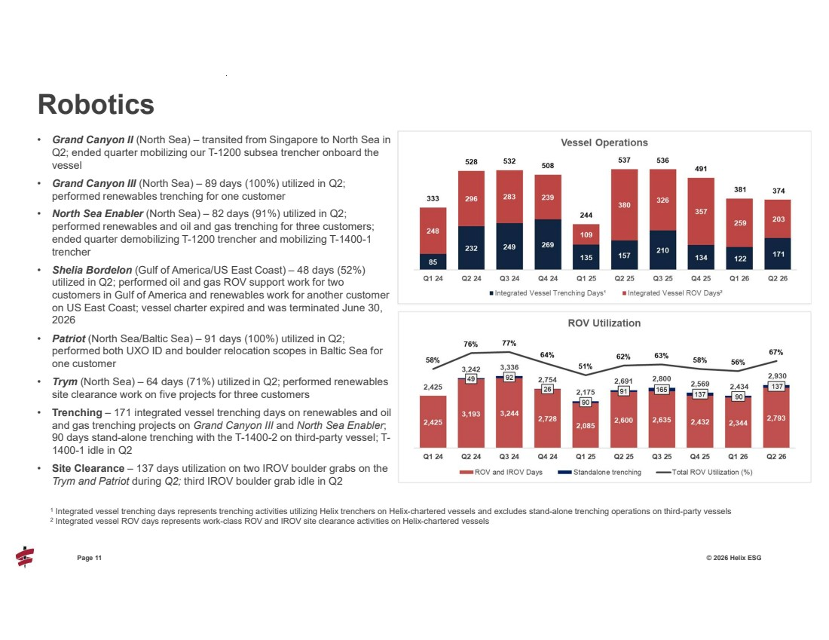 | 11 Page 11 © 2026 Helix ESG • Grand Canyon II (North Sea) – transited from Singapore to North Sea in Q2; ended quarter mobilizing our T-1200 subsea trencher onboard the vessel • Grand Canyon III (North Sea) – 89 days (100%) utilized in Q2; performed renewables trenching for one customer • North Sea Enabler (North Sea) – 82 days (91%) utilized in Q2; performed renewables and oil and gas trenching for three customers; ended quarter demobilizing T-1200 trencher and mobilizing T-1400-1 trencher • Shelia Bordelon (Gulf of America/US East Coast) – 48 days (52%) utilized in Q2; performed oil and gas ROV support work for two customers in Gulf of America and renewables work for another customer on US East Coast; vessel charter expired and was terminated June 30, 2026 • Patriot (North Sea/Baltic Sea) – 91 days (100%) utilized in Q2; performed both UXO ID and boulder relocation scopes in Baltic Sea for one customer • Trym (North Sea) – 64 days (71%) utilized in Q2; performed renewables site clearance work on five projects for three customers • Trenching – 171 integrated vessel trenching days on renewables and oil and gas trenching projects on Grand Canyon III and North Sea Enabler; 90 days stand-alone trenching with the T-1400-2 on third-party vessel; T-1400-1 idle in Q2 • Site Clearance – 137 days utilization on two IROV boulder grabs on the Trym and Patriot during Q2; third IROV boulder grab idle in Q2 Robotics 1 Integrated vessel trenching days represents trenching activities utilizing Helix trenchers on Helix-chartered vessels and excludes stand-alone trenching operations on third-party vessels 2 Integrated vessel ROV days represents work-class ROV and IROV site clearance activities on Helix-chartered vessels
 | 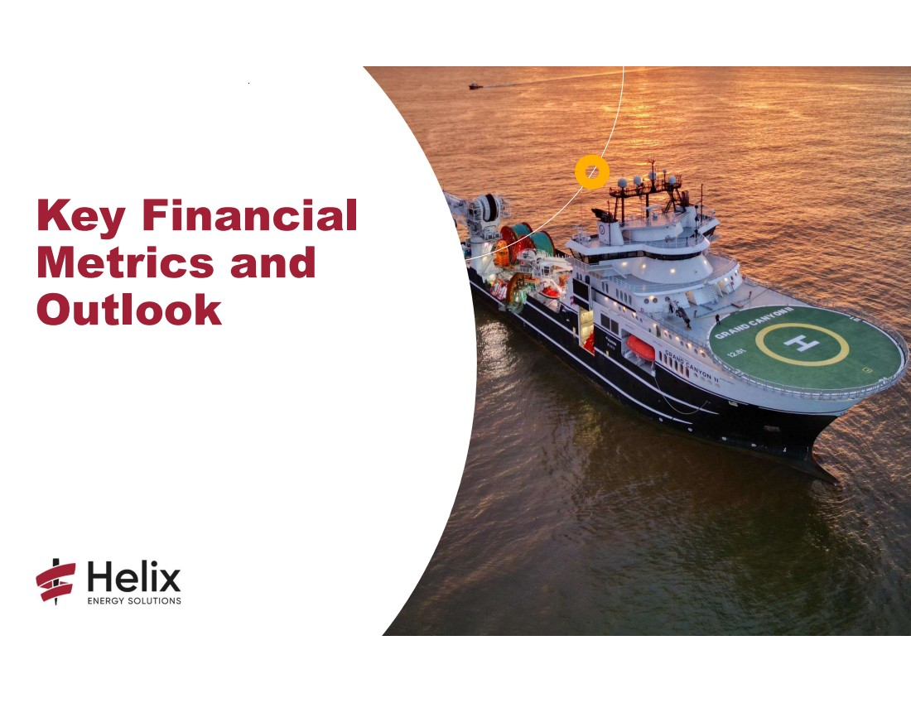 | Key Financial Metrics and Outlook
 | 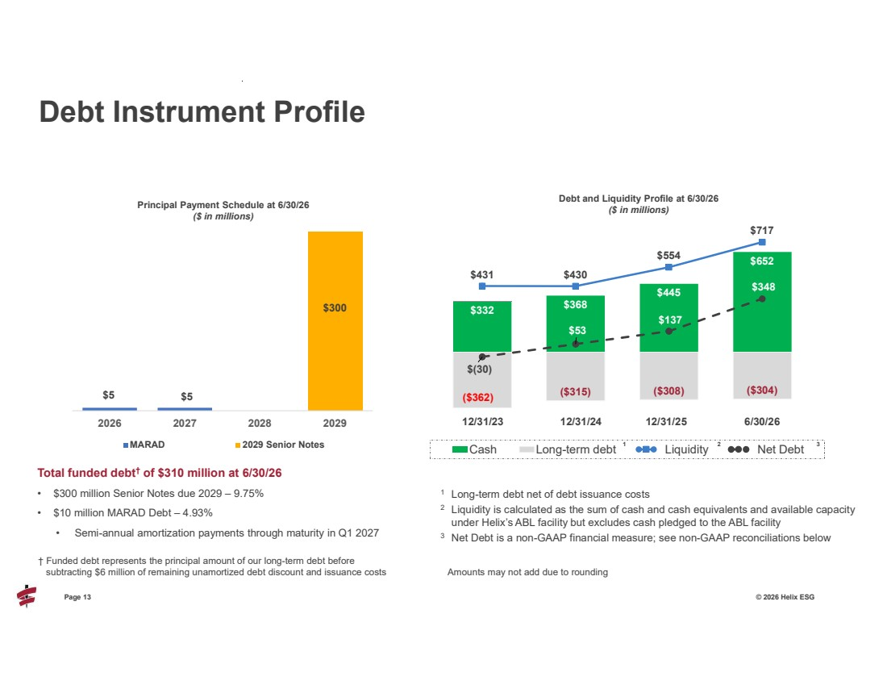 | Page 13 © 2026 Helix ESG Total funded debt† of $310 million at 6/30/26 • $300 million Senior Notes due 2029 – 9.75% • $10 million MARAD Debt – 4.93% • Semi-annual amortization payments through maturity in Q1 2027 Debt Instrument Profile † Funded debt represents the principal amount of our long-term debt before subtracting $6 million of remaining unamortized debt discount and issuance costs $5 $5 $300 2026 2027 2028 2029 Principal Payment Schedule at 6/30/26 ($ in millions) MARAD 2029 Senior Notes $332 $368 $445 $652 ($362) ($315) ($308) ($304) $431 $430 $554 $717 $(30) $53 $137 $348 Cash Long-term debt Liquidity Net Debt 12/31/23 12/31/24 12/31/25 6/30/26 Debt and Liquidity Profile at 6/30/26 ($ in millions) 1 Long-term debt net of debt issuance costs 2 Liquidity is calculated as the sum of cash and cash equivalents and available capacity under Helix’s ABL facility but excludes cash pledged to the ABL facility 3 Net Debt is a non-GAAP financial measure; see non-GAAP reconciliations below 1 2 3 Amounts may not add due to rounding
 | 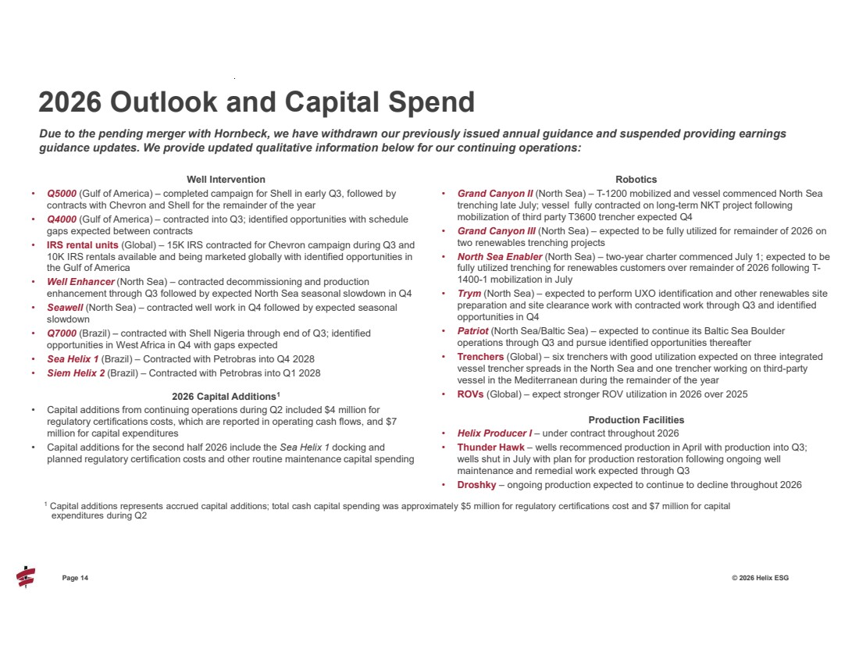 | Page 14 © 2026 Helix ESG Well Intervention • Q5000 (Gulf of America) – completed campaign for Shell in early Q3, followed by contracts with Chevron and Shell for the remainder of the year • Q4000 (Gulf of America) – contracted into Q3; identified opportunities with schedule gaps expected between contracts • IRS rental units (Global) – 15K IRS contracted for Chevron campaign during Q3 and 10K IRS rentals available and being marketed globally with identified opportunities in the Gulf of America • Well Enhancer (North Sea) – contracted decommissioning and production enhancement through Q3 followed by expected North Sea seasonal slowdown in Q4 • Seawell (North Sea) – contracted well work in Q4 followed by expected seasonal slowdown • Q7000 (Brazil) – contracted with Shell Nigeria through end of Q3; identified opportunities in West Africa in Q4 with gaps expected • Sea Helix 1 (Brazil) – Contracted with Petrobras into Q4 2028 • Siem Helix 2 (Brazil) – Contracted with Petrobras into Q1 2028 2026 Capital Additions1 • Capital additions from continuing operations during Q2 included $4 million for regulatory certifications costs, which are reported in operating cash flows, and $7 million for capital expenditures • Capital additions for the second half 2026 include the Sea Helix 1 docking and planned regulatory certification costs and other routine maintenance capital spending Robotics • Grand Canyon II (North Sea) – T-1200 mobilized and vessel commenced North Sea trenching late July; vessel fully contracted on long-term NKT project following mobilization of third party T3600 trencher expected Q4 • Grand Canyon III (North Sea) – expected to be fully utilized for remainder of 2026 on two renewables trenching projects • North Sea Enabler (North Sea) – two-year charter commenced July 1; expected to be fully utilized trenching for renewables customers over remainder of 2026 following T-1400-1 mobilization in July • Trym (North Sea) – expected to perform UXO identification and other renewables site preparation and site clearance work with contracted work through Q3 and identified opportunities in Q4 • Patriot (North Sea/Baltic Sea) – expected to continue its Baltic Sea Boulder operations through Q3 and pursue identified opportunities thereafter • Trenchers (Global) – six trenchers with good utilization expected on three integrated vessel trencher spreads in the North Sea and one trencher working on third-party vessel in the Mediterranean during the remainder of the year • ROVs (Global) – expect stronger ROV utilization in 2026 over 2025 Production Facilities • Helix Producer I – under contract throughout 2026 • Thunder Hawk – wells recommenced production in April with production into Q3; wells shut in July with plan for production restoration following ongoing well maintenance and remedial work expected through Q3 • Droshky – ongoing production expected to continue to decline throughout 2026 2026 Outlook and Capital Spend Due to the pending merger with Hornbeck, we have withdrawn our previously issued annual guidance and suspended providing earnings guidance updates. We provide updated qualitative information below for our continuing operations: 1 Capital additions represents accrued capital additions; total cash capital spending was approximately $5 million for regulatory certifications cost and $7 million for capital expenditures during Q2
 | 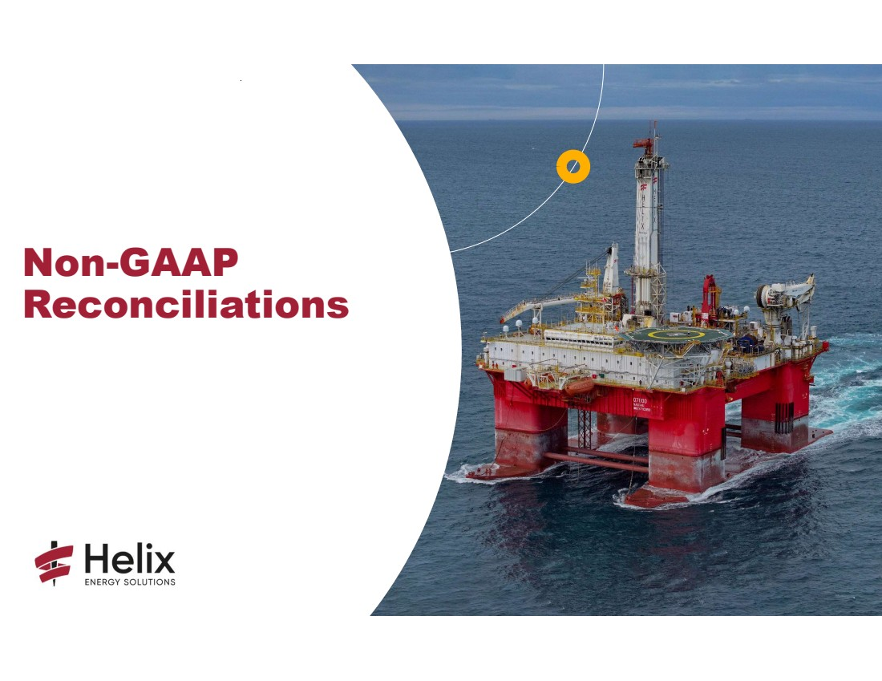 | Non-GAAP Reconciliations
 | 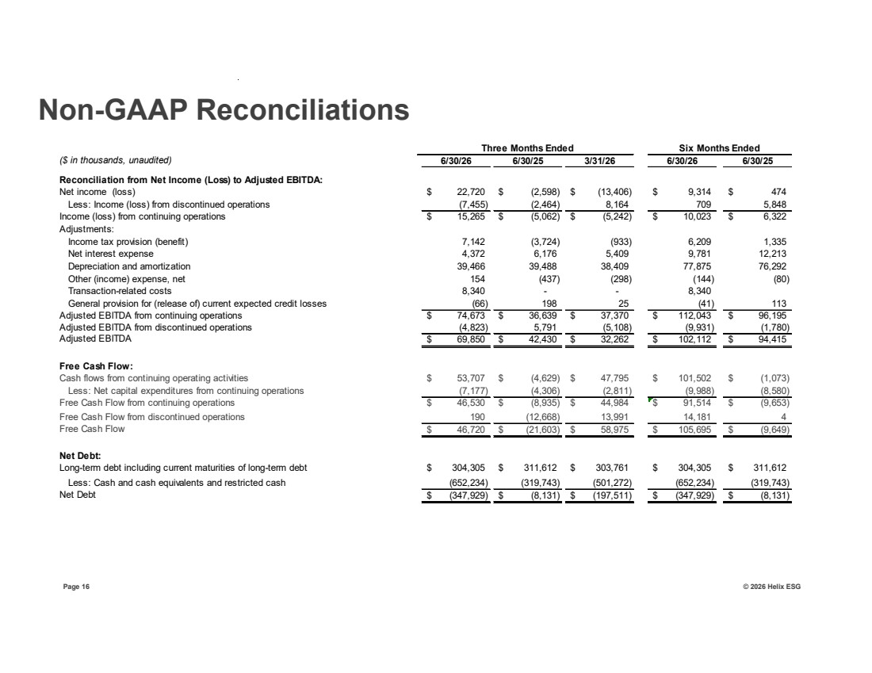 | Page 16 © 2026 Helix ESG Non-GAAP Reconciliations ($ in thousands, unaudited) 6/30/26 6/30/25 3/31/26 6/30/26 6/30/25 Reconciliation from Net Income (Loss) to Adjusted EBITDA: Net income (loss) 22,720 $ (2,598) $ (13,406) $ 9,314 $ 474 $ Less: Income (loss) from discontinued operations (7,455) (2,464) 8,164 709 5,848 Income (loss) from continuing operations 15,265 $ (5,062) $ (5,242) $ 10,023 $ 6,322 $ Adjustments: Income tax provision (benefit) 7,142 (3,724) (933) 6,209 1,335 Net interest expense 4,372 6,176 5,409 9,781 12,213 Depreciation and amortization 39,466 39,488 38,409 77,875 76,292 Other (income) expense, net 154 (437) (298) (144) (80) Transaction-related costs 8,340 - - 8,340 General provision for (release of) current expected credit losses (66) 198 25 (41) 113 Adjusted EBITDA from continuing operations $ 74,673 $ 36,639 $ 37,370 $ 112,043 $ 96,195 Adjusted EBITDA from discontinued operations (4,823) 5,791 (5,108) (9,931) (1,780) Adjusted EBITDA $ 42,430 69,850 $ 32,262 $ 102,112 $ 94,415 $ Free Cash Flow: Cash flows from continuing operating activities 53,707 $ (4,629) $ 47,795 $ 101,502 $ (1,073) $ Less: Net capital expenditures from continuing operations (7,177) (4,306) (2,811) (9,988) (8,580) Free Cash Flow from continuing operations $ (8,935) 46,530 $ 44,984 $ 91,514 $ (9,653) $ Free Cash Flow from discontinued operations 190 (12,668) 13,991 14,181 4 Free Cash Flow $ (21,603) 46,720 $ 58,975 $ 105,695 $ (9,649) $ Net Debt: Long-term debt including current maturities of long-term debt 304,305 $ 311,612 $ 303,761 $ 304,305 $ 311,612 $ Less: Cash and cash equivalents and restricted cash (652,234) (319,743) (501,272) (652,234) (319,743) Net Debt $ (8,131) (347,929) $ (197,511) $ (347,929) $ (8,131) $ Three Months Ended Six Months Ended
 | 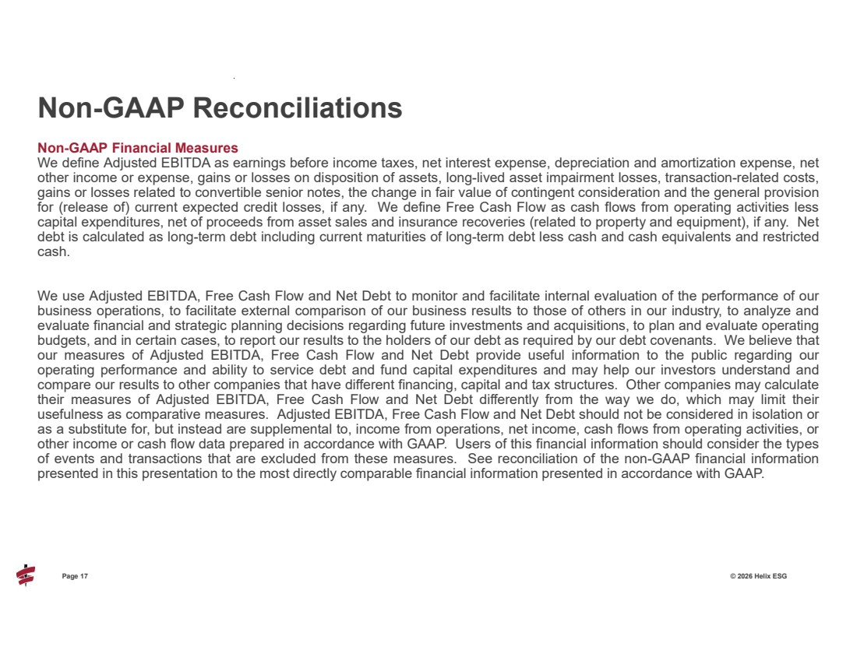 | Page 17 © 2026 Helix ESG Non-GAAP Financial Measures We define Adjusted EBITDA as earnings before income taxes, net interest expense, depreciation and amortization expense, net other income or expense, gains or losses on disposition of assets, long-lived asset impairment losses, transaction-related costs, gains or losses related to convertible senior notes, the change in fair value of contingent consideration and the general provision for (release of) current expected credit losses, if any. We define Free Cash Flow as cash flows from operating activities less capital expenditures, net of proceeds from asset sales and insurance recoveries (related to property and equipment), if any. Net debt is calculated as long-term debt including current maturities of long-term debt less cash and cash equivalents and restricted cash. We use Adjusted EBITDA, Free Cash Flow and Net Debt to monitor and facilitate internal evaluation of the performance of our business operations, to facilitate external comparison of our business results to those of others in our industry, to analyze and evaluate financial and strategic planning decisions regarding future investments and acquisitions, to plan and evaluate operating budgets, and in certain cases, to report our results to the holders of our debt as required by our debt covenants. We believe that our measures of Adjusted EBITDA, Free Cash Flow and Net Debt provide useful information to the public regarding our operating performance and ability to service debt and fund capital expenditures and may help our investors understand and compare our results to other companies that have different financing, capital and tax structures. Other companies may calculate their measures of Adjusted EBITDA, Free Cash Flow and Net Debt differently from the way we do, which may limit their usefulness as comparative measures. Adjusted EBITDA, Free Cash Flow and Net Debt should not be considered in isolation or as a substitute for, but instead are supplemental to, income from operations, net income, cash flows from operating activities, or other income or cash flow data prepared in accordance with GAAP. Users of this financial information should consider the types of events and transactions that are excluded from these measures. See reconciliation of the non-GAAP financial information presented in this presentation to the most directly comparable financial information presented in accordance with GAAP. Non-GAAP Reconciliations
 | 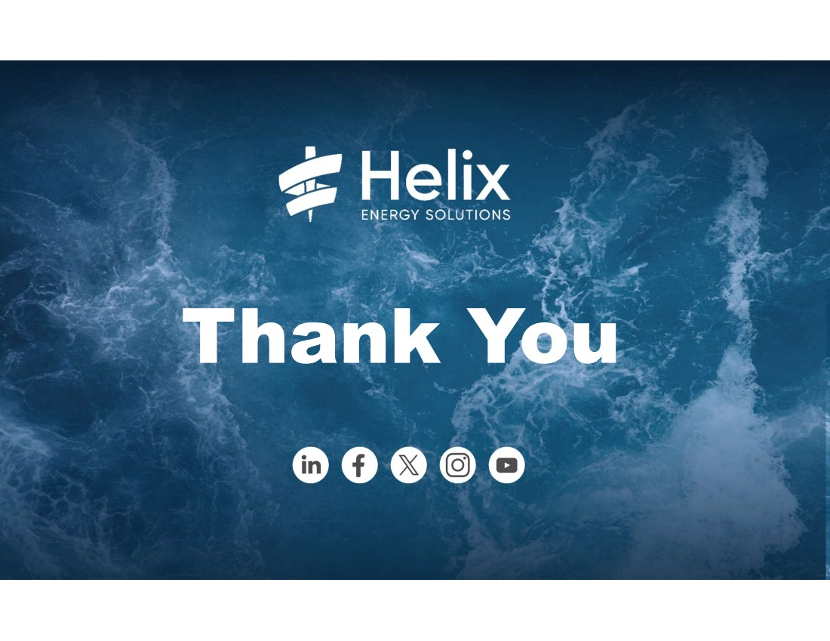 | 18 Page 18 © 2026 Helix ESG

